Note:
1、NVR_HIWIFI3798_9_v7.1.38.2 Previous version upgrade to NVR_HIWIFI3798_9_v7.1.38.2 version, need to reformat the hard disk , if there are important video, you need to do backup and then upgrade;
2、the normal upgrade is to use manual upgrade first, if upgrade failed then use automatic upgrade

Manual upgrade
Local end manual upgrade
1.Cope upgrade files (named as xxxxx_update_x_Vx.x.xx.x.bin or xxxxx_updateVx.x.xx.x.bin) to the root directory of U, insert the NVR USB port, right click menu click Menu->Maintenance->Manual Update to enter the manual upgrade interface.
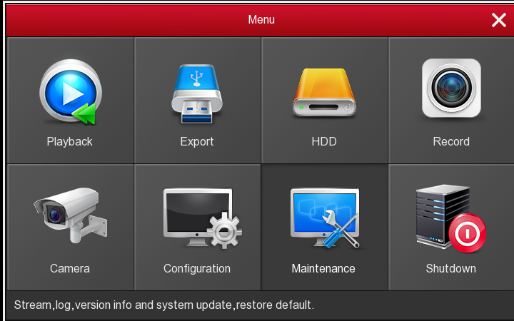
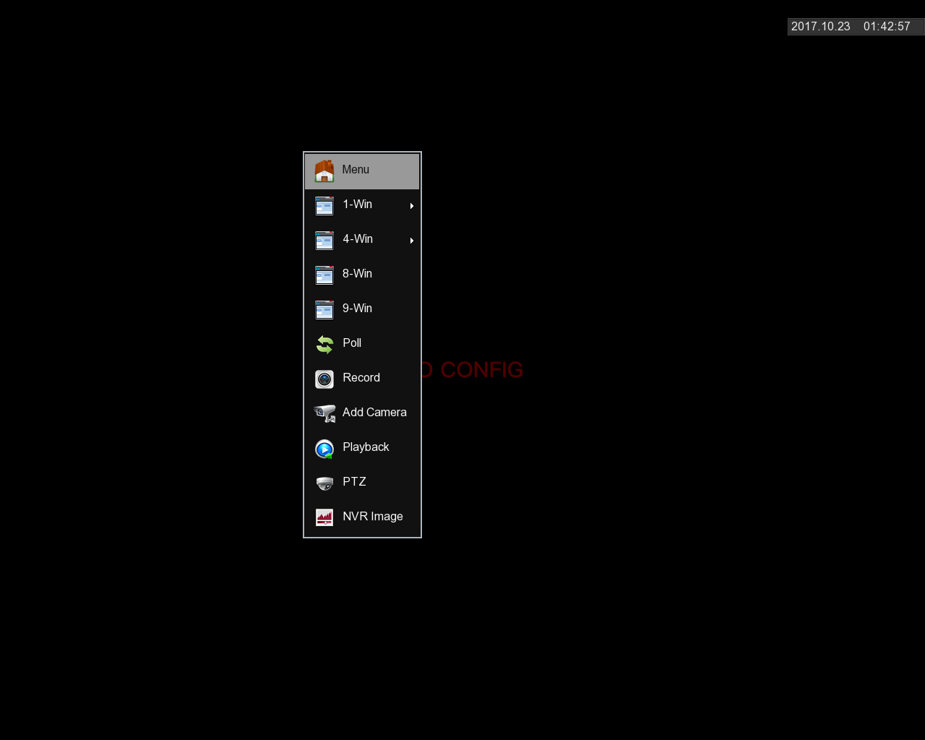

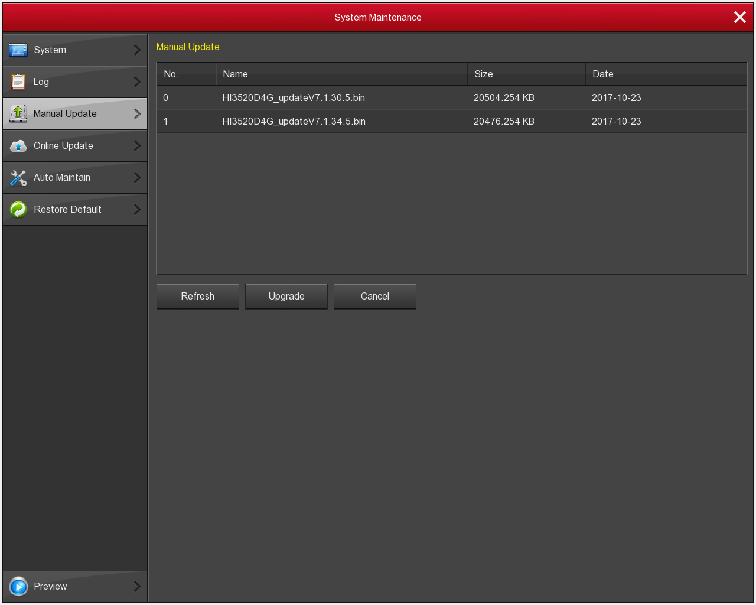
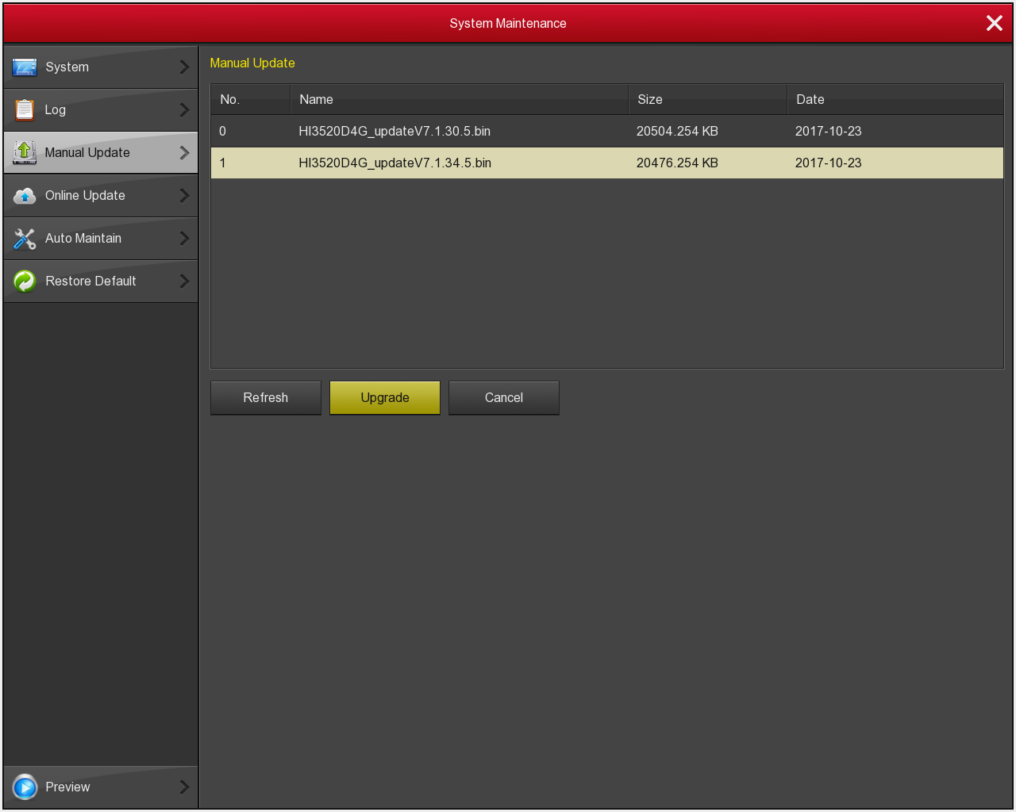

2.If the the upgrade file does not appear in the list, please refresh the page (attempts to refresh many times if undetectable upgrade package, please check the connection between the disk U and USB port is good contact, the upgrade file name is correct), when upgrade file appears, select the file, click "Upgrade" to start the upgrade.

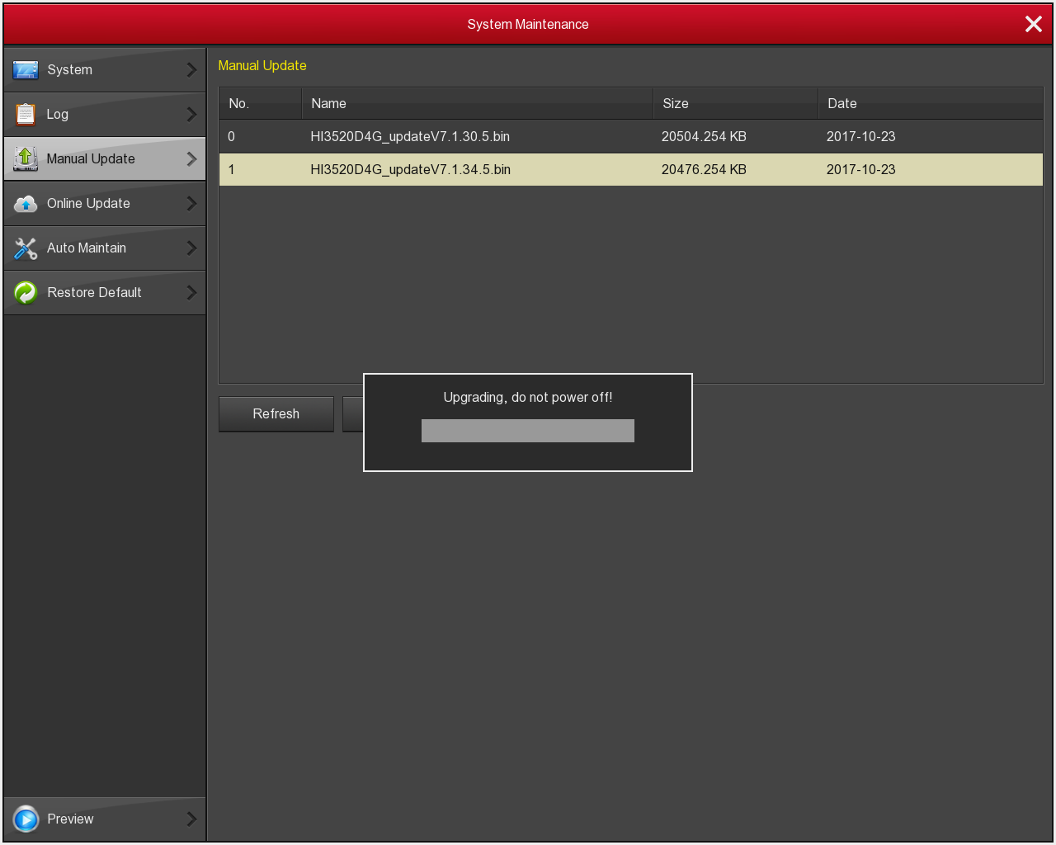

Manual upgrade of OCX terminal
1.Open the OCX and log in with admin users, click Configuration->Maintain->Manual Upgrade, enter the manual upgrade interface.

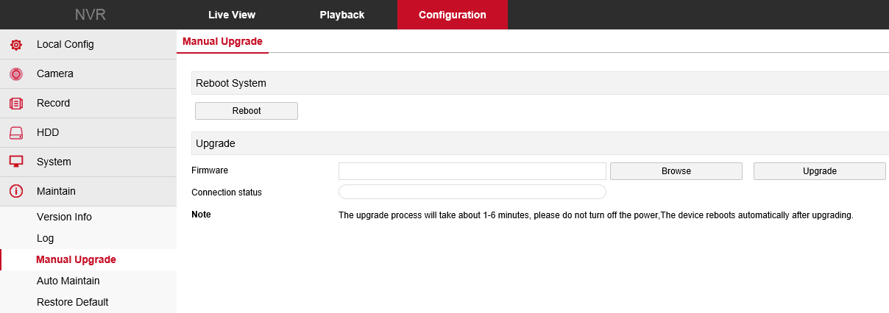
2.Click Browse, select the upgrade file (named xxxxx_update_x_Vx.x.xx.x.bin or xxxxx_updateVx.x.xx.x.bin), click Upgrade, pop up the prompt box, and the device starts to upgrade
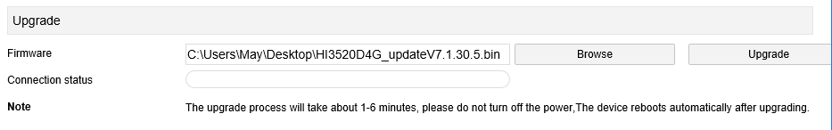

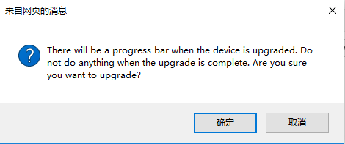

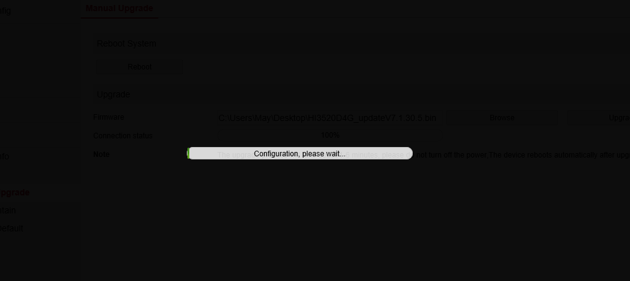

Automatic Updates
Copy the automatic file named XXXXXX_AutoUpdate into the root directory of U, and then inserted into the corresponding NVR equipment, reboot the device can enter the automatic upgrade interface, after the upgrade is complete , equipment will automatically restart (when rebooting the device please unplug the U disk).
